emissions_by_sector_summary

William F. Lamb

# Setup

## Growth rate calculation

# Data

## Gather trend data

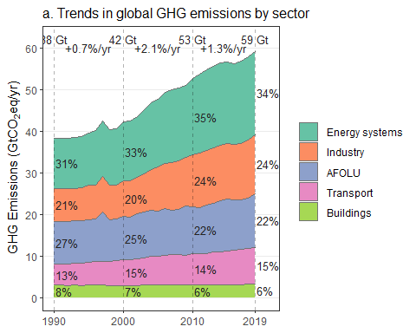

## Gather region data

